Defect Metrics

🔹 Definition
# Source: Chatgpt (GPT-5-Standard) at [8/18/2025]
Defect Metrics are measurements used to track and analyze software defects (bugs) during the testing and development process.
They provide insights into defect trends, severity, root causes, and overall product quality.
👉 In short: They answer the question – “What do defects tell us about the quality of the software and the effectiveness of our testing?”

🛠️ Key Defect Metrics

1. Defect Density
# Source: Chatgpt (GPT-5-Standard) at [8/18/2025]
- What: Number of defects relative to the size of the software.
- Formula:
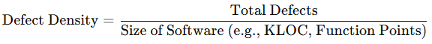
Defect Density=Total DefectsSize of Software (e.g., KLOC, Function Points)\text{Defect Density} = \frac{\text{Total Defects}}{\text{Size of Software (e.g., KLOC, Function Points)}}
- Example: 50 defects / 10,000 LOC = 0.005 defects per LOC.
📌 Helps compare quality between modules or releases.

2. Defect Severity Index (DSI)
# Source: Chatgpt (GPT-5-Standard) at [8/18/2025]
- What: Average severity of all reported defects.
- Formula:
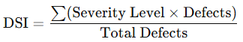
DSI=∑(Severity Level×Defects)Total Defects\text{DSI} = \frac{\sum (\text{Severity Level} \times \text{Defects})}{\text{Total Defects}}
📌 Higher DSI → More critical issues → Riskier product.

3. Defect Leakage (Escape Rate)
# Source: Chatgpt (GPT-5-Standard) at [8/18/2025]
- What: Percentage of defects that escaped testing and were found in production.
- Formula:
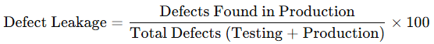
Defect Leakage=Defects Found in ProductionTotal Defects (Testing + Production)×100\text{Defect Leakage} = \frac{\text{Defects Found in Production}}{\text{Total Defects (Testing + Production)}} \times 100
- Example: 10 defects found in production / 100 total defects = 10% leakage.

4. Defect Removal Efficiency (DRE)
# Source: Chatgpt (GPT-5-Standard) at [8/18/2025]
- What: How effectively testing removes defects before release.
- Formula:
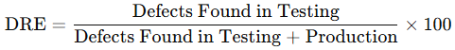
DRE=Defects Found in TestingDefects Found in Testing + Production×100\text{DRE} = \frac{\text{Defects Found in Testing}}{\text{Defects Found in Testing + Production}} \times 100
- Example: 90 defects in testing, 10 in production → DRE = 90%.

5. Defect Age
# Source: Chatgpt (GPT-5-Standard) at [8/18/2025]
- What: Time taken to detect or fix a defect after it was introduced.
- Measured As:
  - Detection Age: (Defect detection date – defect injection date).
  - Fix Age: (Defect fix date – detection date).
📌 Helps evaluate responsiveness.

6. Defect Resolution Time
# Source: Chatgpt (GPT-5-Standard) at [8/18/2025]
- What: Average time taken to fix and close a defect.
- Formula:
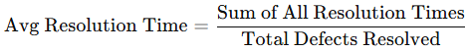
Avg Resolution Time=Sum of All Resolution TimesTotal Defects Resolved\text{Avg Resolution Time} = \frac{\text{Sum of All Resolution Times}}{\text{Total Defects Resolved}}

7. Defect Distribution
# Source: Chatgpt (GPT-5-Standard) at [8/18/2025]
- What: Categorization of defects by module, severity, priority, phase of origin, or type (UI, logic, performance, etc.).
📌 Helps identify high-risk areas.

8. Defect Rejection Rate
# Source: Chatgpt (GPT-5-Standard) at [8/18/2025]
- What: % of defects reported by testers but rejected by developers (as not valid, duplicate, or “works as designed”).
- Formula:
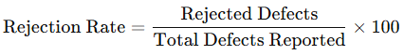
Rejection Rate=Rejected DefectsTotal Defects Reported×100\text{Rejection Rate} = \frac{\text{Rejected Defects}}{\text{Total Defects Reported}} \times 100
📌 High rejection rate → issues with test case design or communication.

📊 Example Summary (Banking App Release)
# Source: Chatgpt (GPT-5-Standard) at [8/18/2025]
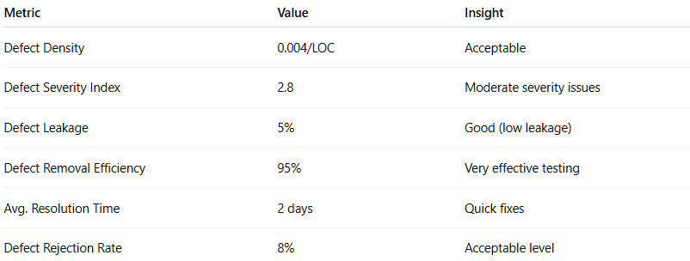
Metric | Value | Insight
Defect Density | 0.004/LOC | Acceptable
Defect Severity Index | 2.8 | Moderate severity issues
Defect Leakage | 5% | Good (low leakage)
Defect Removal Efficiency | 95% | Very effective testing
Avg. Resolution Time | 2 days | Quick fixes
Defect Rejection Rate | 8% | Acceptable level

✅ Why Defect Metrics Matter
# Source: Chatgpt (GPT-5-Standard) at [8/18/2025]
- Measure testing effectiveness.
- Provide insights into product quality.
- Help prioritize fixes (based on severity/priority).
- Support process improvement by analyzing defect trends.

👉 In short: Defect Metrics = indicators that show the quality of the product and the efficiency of the testing process in finding & resolving bugs.

